Lab 2
Natnael Kebede
Section 1

- Screen capture showing the contents of the Ports/Hosts tab from the SYN scan for 172.30.0.10
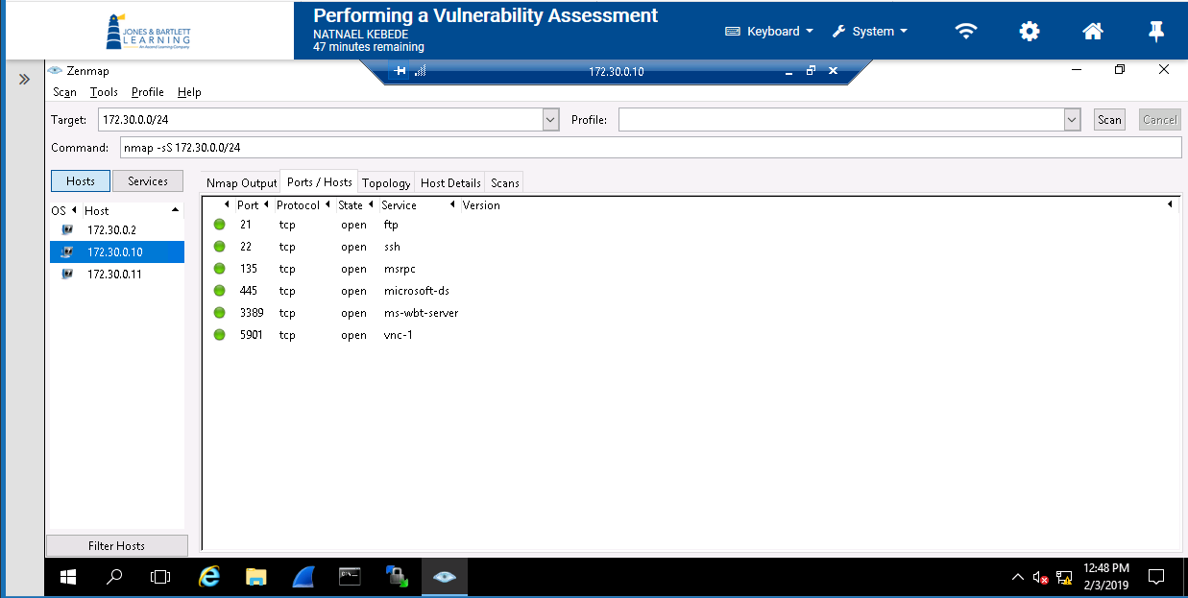
- Screen capture showing the contents of the host details tab from the OS scan for 172.30.0.2
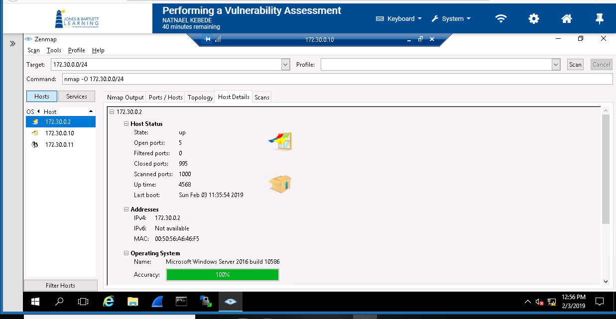

- Screen capture showing the details in the ports/hosts tab from the service scan for 172.30.0.11
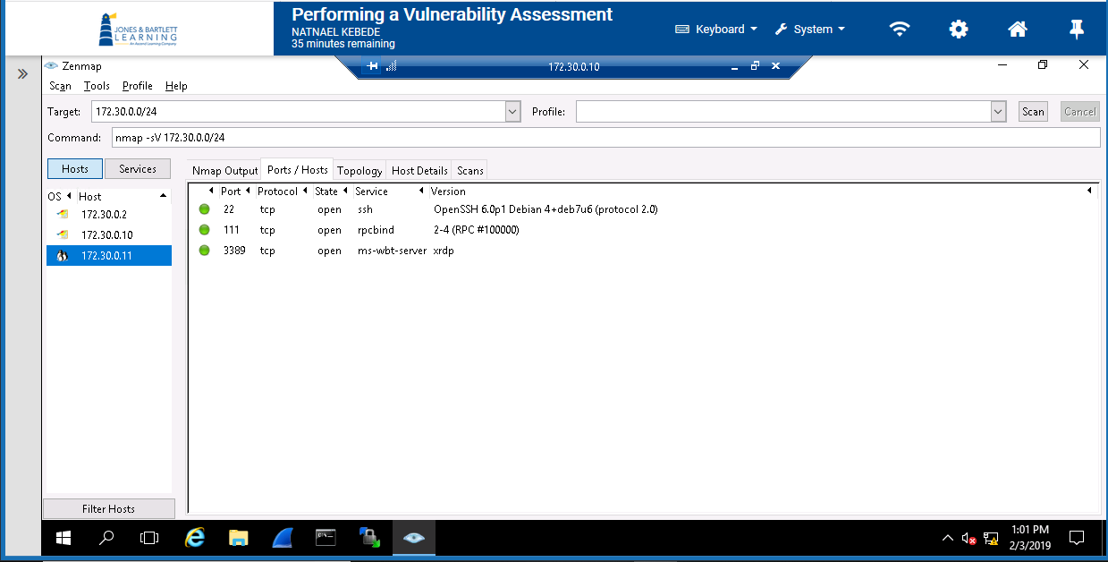

Section 2
- Screen capture showing the host details tab from the TCP connection scan for 172.30.0.2
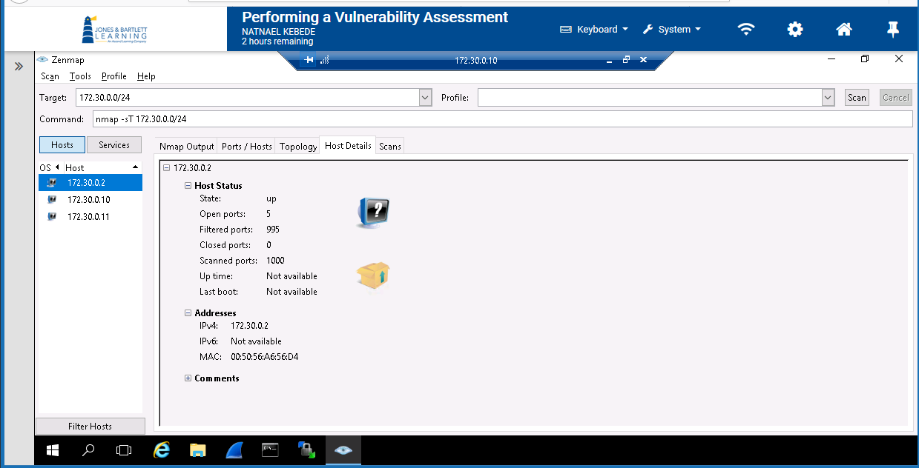

- Screen capture showing the host details tab from the SYN scan for 172.30.0.11
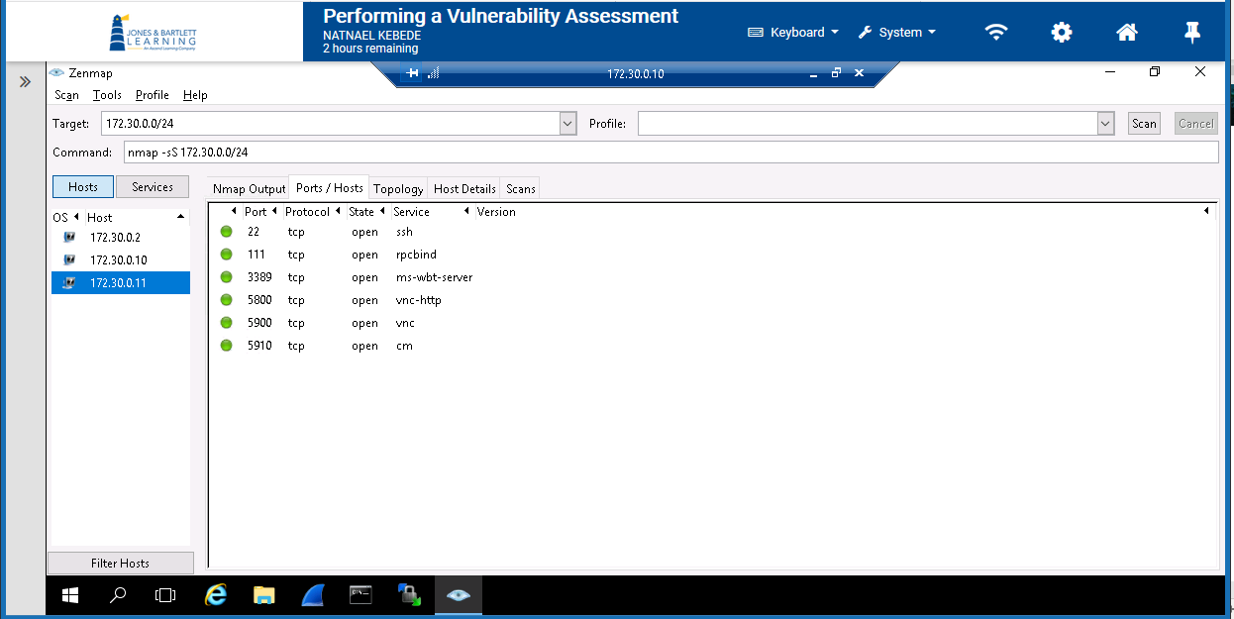
- Screen capture showing the details in the Ports/Hosts tab from the Service scan for 172.30.0.10
